HEALTH CHECK COMMITTEE

PURPOSE: The Health Check Committee exists to support small groups in maintaining the health of the group and in helping members grow in their journey to “real men, real disciples.” They assist groups who might be losing energy, dropping in member engagement, or experiencing “mission drift” where the group is moving away from FinD’s mission. In many cases, these meetings are an exchange of ideas – a sharing of best practices. Every group that has had a health check has walked away saying, “why didn’t we do this a long time ago and do it every year or two?”. This committee also administers an Annual Member Survey which typically rolls out in early Q1 as a lookback on the prior year for the ministry.

Transforming men through Jesus Christ in authentic, weekly Fellowship in Discipleship

RESOURCES PROVIDED:
The Health Check Committee shares resources with groups including assessment tools (Health Check Framework and High Low Tool). The committee does an Annual Member Survey across all the FinD small groups which enables identification of best practices to share across the membership, new ideas to incorporate, and issues to be addressed. The following are resources available to small groups.

Small Group Resources | FinD has compiled a set of resources for utilization with our small groups which help members disciple one another as they mutually pursue growth in Christ. Small Group Documents - FinD (finddiscipleship.org)
Health Check Framework

The Health Check Framework provides a 3-tiered process to help small groups make sure they are on track as a small group and are focusing on the mission of FinD.
- Tier 1 – Self Evaluation: This is a periodic evaluation (suggested once per year) that a small group can do to check that things are going well before any problems arise. Each group member evaluates the group using guiderails and then discuss as a group and agree actions. The guiderails include 7 measures of an effective group including fellowship, accountability, transparency, and full participation.
- Tier 2 – Peer Evaluation: This evaluation is done as needed when the group is facing issues (i.e. lack of engagement) and could benefit from some external perspective. A representative from one small group meets with someone from another small group and uses the “Guiderails” to discuss approaches taken and results to address a group issue.
- Tier 3 – Lifeline: If the group is facing a serious issue and needs a course correction, they can reach out if significant external input would help. Serious issues might include when a group member violates confidentiality resulting in a lack of trust. The FinD Board will designate someone to meet with the small group to provide evaluation and support to get the group back on track.
NOTE: Tier 3 is used when all group members agree this external help is needed.

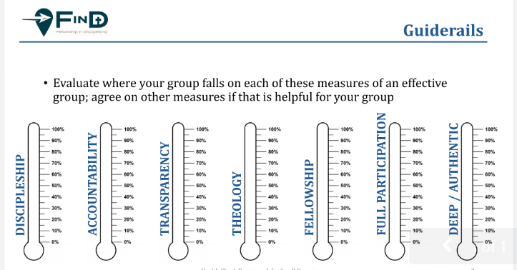
HIGH LOW TOOL

The FinD High-Low tool is a proven way for small groups to go deeper in their understanding of one another as members share the highs and lows in aspects of their lives (business, personal, spiritual) as well as what they are facing on the horizon. The High-Low session is a separate session but can provide insights to a small group’s Health Check. https://finddiscipleship.org/wp-content/uploads/2021/04/FinD-High-Low-Guidelines-with-Table-Updated-2021-04.pdf

GOALS FOR 2022:

The Health Check Committee plans to enhance the resources they offer as follows:

- Annual Member Survey (All FinD Small Groups): Take the results of the annual survey and work with the FinD Board, Committee Chairs, and Discipleship Council to incorporate those into the FinD strategy.
- Health Check Tool (Guiderails Used by Individual Small Groups): Develop an online survey that more extensively identifies group dynamic shortfalls. Potentially develop a survey that can be used in the Tier 2 Peer Evaluations.

